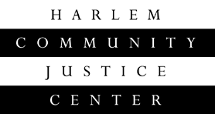
Applicant Questionnaire for “Raising My Voice: Speakers Bureau”

Name:________________________________________________ Date:______________________
Home address:_____________________________________ Phone number: ________

How did you hear about the training?

_________________________________________________________________________
Why would you like to take part in this training?

_________________________________________________________________________

What skills or strengths do you already possess that would aid you in completing the training?

_________________________________________________________________________
What interests you most about Public Speaking?

How will this training benefit you in your life?

_________________________________________________________________________

What challenges do you feel you may encounter completing the training?

_________________________________________________________________________

Completed questionnaires should be emailed to Linda Steele:
lsteele@nycourts.gov, sent to
Linda Steele, Workforce Development Coordinator, Harlem Community Justice Center 121 E. 170th Street, New York, New York 10035, or dropped off (by appointment only).
For questions, or to drop off an application, please call Linda at
(212) 360-4117 or at
(347) 410-1782.

Upon review of the questionnaire, you will be contacted if we are interested in interviewing you.

