  Picture yourself here!!
    - “RAISING YOUR VOICE”: A SPEAKERS BUREAU OF FORMERLY INCARCERATED INDIVIDUALS
    - Interview DATES & TIMES: June 27, 2014 2PM-5PM
    - june 30, 2014 9am-4pm
    - TRAINING DATES & TIMES:
    - Every monday beginning july 7, 2014 6pm-8PM
    - GRADUATION sEPTEMBER 12, 2014 6PM-8PM
    - a light meal will be provided before each training from 5PM-6PM, metro cards AND modest stipend also provided
    - LOCATION: To Be Announced
  What is “RAISING YOUR VOICE”? RAISING YOUR VOICE is a leadership, public speaking, and civic engagement initiative designed for men and women who have experienced first-hand the impacts of incarceration and reentry and want to share their story.
  RAISING YOUR VOICE will offer you the skills and the opportunity to give back to your community and inspire communities to join the fight to ease the reentry process for men and women coming home from prison. Along the way, you will learn valuable employment skills including public speaking and marketing yourself!
  reentry effort’s
  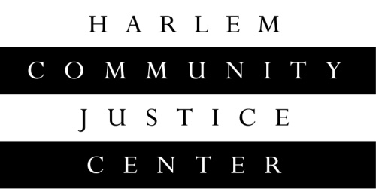
  Have you returned home from prison and demonstrated a commitment to changing your life?
  Interested in gaining valuable leadership and public speaking skills?
  Want to raise awareness for the challenges you faced in reentry and give back to your community?
  TO BECOME A “RAISING YOUR VOICE” Speakers Bureau Member:
  To get an application, email Linda Steele, Workforce Development Coordinator at lsteele@nycourts.gov or call
  (212) 360-4117 or (347) 410-1782.
  www.courtinnovation.org

